Y SENSOR CABLE

- PARTS:

QUANTITY: PART #: NOMENCLATURE: LENGTH:

1 PER MACHINE 19224-3 CABLE, FLT-RBN, 10-CON, 24 AWG 81 INCHES

2 PER MACHINE 17464-1 CONNECTOR, SOCKET W/RELIEF N/A

- ASSEMBLY:

- CAREFULLY ALIGN THE WIRES ON THE PINS OF THE CONNECTOR.

- MAKE SURE THE BROWN WIRE IS ALIGNED WITH THE ARROW ON THE CONNECTOR, ACCORDING TO DIAGRAM 1.

NOTE 1
IT IS CRITICAL THAT THE BROWN WIRE IS ALIGNED WITH THE ARROW ON THE CONNECTOR. ANY VARIATION WILL RESULT IN FUNCTIONAL FAILURE OR DAMAGE TO CIRCUITRY.

- ATTACH AND PRESS THE CONNECTOR COVER WHILE MAINTAINING THE WIRE/PIN ALIGNMENT,

- SQUEEZE THE COVER ONTO THE CONNECTOR USING A VISE TO ENSURE A HARD CONNECTION.

- PERFORM STEPS 2A THROUGH 2D FOR THE CONNECTION AT THE OPPOSITE END OF THE CABLE.

- USE THE TEST JIG CONNECTORS AND MULTIMETER TO TEST FOR SHORTING OR OPEN CONDITIONS IN THE CONNECTIONS OF THE FINISHED CABLE.

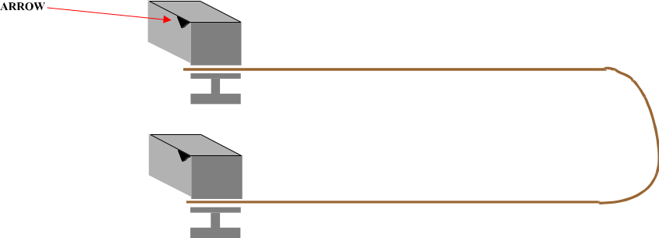
DIAGRAM 1

